

De La Salle University

College of Computer Studies

Software Technology Department

**CheckUp**

SOFTWARE REQUIREMENTS SPECIFICATION

|  |  |
| --- | --- |
| **Team Name** | **CHOCNATS** |
| **Section** | S19B |
| **Team Members** | Acorda, Victoria  Aquino, Kurt  Caingles, John  Choa, Shaila  Dionio, William  Enomoto, Yuki  Estioko, Jerrick  Matias, Gelo  Mendaros, Naomi  Susada, Jan |
| **Date Submitted** | March 18, 2015 |

**Table of Contents**

|  |  |
| --- | --- |
| 1 Executive Summary | 1 |
| 2 Overview | 2 |
| 2.1 Existing Business Process | 2 |
| 2.2 Data Requirements | 4 |
| 2.3 Roles in the Business Process | 8 |
| 3 Problem Analysis | 9 |
| 4 Software Solution | 11 |
| 4.1 Objectives | 11 |
| 4.2 Characteristics | 11 |
| 5 User Stories | 12 |
| 5.1 <User Story 1> | 12 |
| 5.2 <User Story 2> | 13 |
| 5.3 <User Story 3> | 14 |
| 5.4 <User Story 4> | 15 |
| 5.5 <User Story 5> | 16 |
| 5.6 <User Story 6> | 17 |
| 5.7 <User Story 7> | 18 |
| 5.8 <User Story 8> | 19 |
| 5.9 <User Story 9> | 20 |
| 5.10 <User Story 10> | 21 |
| 5.11 <User Story 11> | 22 |
| 5.12 <User Story 12> | 23 |
| 5.13 <User Story 13> | 24 |
| 5.14 <User Story 14> | 25 |
| 5.15 <User Story 15> | 26 |
| 5.16 <User Story 16> | 27 |
| 5.17 <User Story 17> | 28 |
| 5.18 <User Story 18> | 29 |
| Appendix A - Improved Business Process | 30 |
| Appendix B - Interview Transcript | 31 |
| Appendix C - Sample Forms and Reports | 52 |
| Appendix D - References and Acknowledgements | 60 |

**1** **Executive Summary**

Jovy Abong is a physician for twenty-nine years that specializes in Internal Medicine and has a subspecialty with Allergology and Immunology. Dr. Abong is presently connected with four hospitals in the Philippines, namely Asian Hospital (Alabang), Manila Doctors Hospital, Philippine General Hospital, and De La Salle University in Dasmarinas Cavite, where she practices her subspecialty. She is also the president of the Philippine Society of Allergy, Asthma and Immunology, Inc. at the Philippine Medical Association. At the same time, she’s a professor in the College of Medicine of University of the Philippines - Manila and De La Salle University - Dasmarinas.

Asian Hospital and Medical Center, located in the Filinvest City in Alabang, Muntinlupa City, is a tertiary hospital accredited by the Joint Commission International (JCI), the world’s most prestigious accrediting body for health care organizations. It is a part of the Metro Pacific Hospital Group, a group of hospitals managed by the Metro Pacific Investments Corporation (MPIC), the local unit of the First Pacific Group headed by Manuel V. Pangilinan. They have 1,000 expert doctors from different specialties who have been trained in top institutions worldwide. Asian Hospital also has over 1,000 highly skilled employees and staff to provide high quality and compassionate patient care.

Philippine Medical Association is part of the World Medical Association. The PMA, also a member of the Medical Associations of South East Asian Nations (MASEAN) has 118 Component Medical Societies in its 17 Regions all over the country. Affiliated with the PMA are the 8 Specialty Divisions: Philippine Academy of Family Physicians (PAFP), Philippine College of Physicians (PCP), Philippine Obstetrical and Gynecological Society (POGS), Philippine Pediatric (PPS), Philippine College of Surgeons (PCS), Philippine Society of Anesthesiologists (PSA), Philippine College of Radiology (PCR), and Philippine Society of Pathologists (PSP) with its specialties and sub-specialties and 36 affiliate medical societies.

**2** **Overview of the Business Process**

***2.1 Existing Business Process***

On an ordinary day, the patient visits the clinic for a check-up. If the patient has an existing medical record *Allergy and ADR form* (see Appendix C-1), the secretary will then retrieve the record. On the other hand, if the patient doesn’t have any record at all the secretary will ask for a blank form from the physician. The secretary then interviews the patient and fills up the form with the general data (personal information) of the patient. The form will then be forwarded to the physician to be reviewed, and the patient will be asked to wait patiently before being called by the physician.

Once received by the attending physician, the patient is interviewed regarding his or her complaint. The patient then undergoes a series of questions and physical exam regarding any symptoms or complications that can be referenced with the patient’s chief complaint. After the exam, the physician writes down any of his findings and starts to diagnose the patient if the patient needs to undergo any lab test or if surgery or treatment is necessary. The physician then issues the prescribe medication or treatment necessary to address the complaint. Afterwards, the medical record is updated and given back to the secretary.

Once every month a physician will be assigned to collate the data for census. The assigned physician will asks the medical record from the departmental secretary. The secretary gives all the medical records to the physician. The physician then retrieves a medical record from the pile of records and tallies the necessary data for census. The physician gets another medical record and tallies again until all the medical record is accounted for. After all the data has been tallied or accounted for, the physician returns all the medical records to the departmental secretary.

The business process can be visualized in the diagram shown in Figure 2-1.

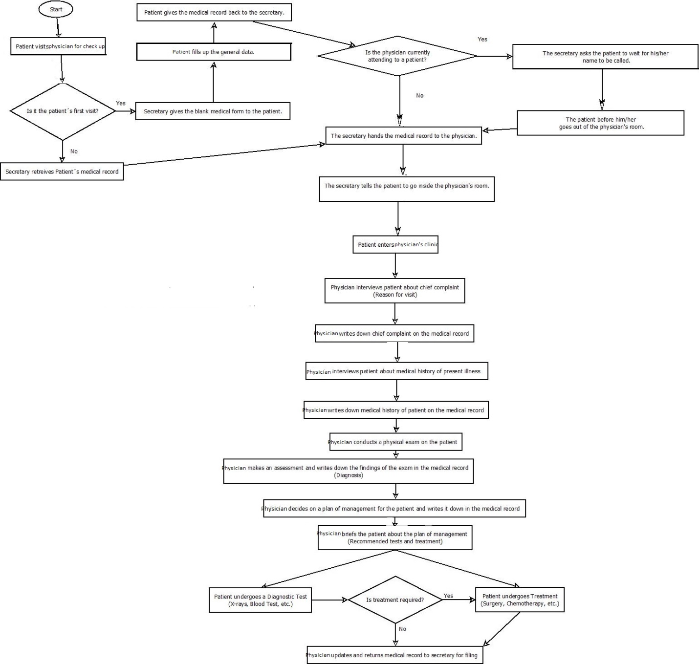

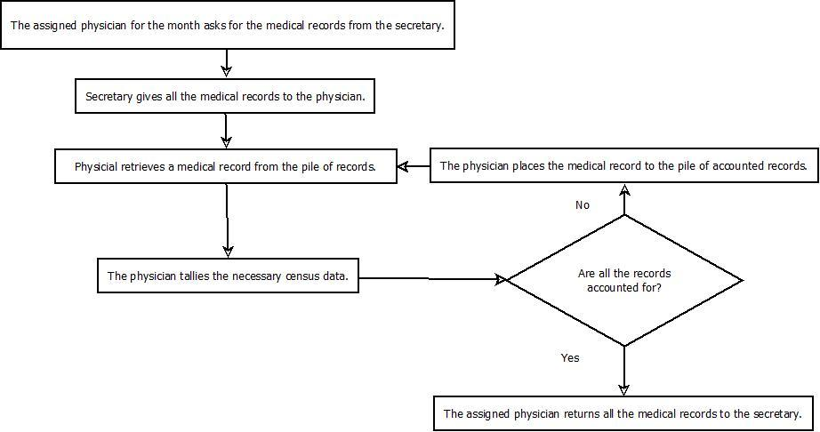

*Figure 2-1. Existing Business Process*

***2.2 Data Requirements***

An Allergy and ADR Form (see Appendix C-1) that is collected by the attending physician contains the following personal information namely, patient’s complete name, case number, age, sex, status, date that the data was taken, birthday, birthplace, address, contact number, source of referral, informant and reliability.

It also contains the chief complaint, history of present illness, age of onset *(< 1mo / 1-6mo / 7-12mo / 1-5yrs / 5-10yrs / 10-20yrs / 20-30yrs / 30-40yrs / 40-50yrs / 50-60 yrs / >) 60 yrs* , duration of illness (: < 1mo / ____ mo / ____ yr; since ____ ), time of occurrence (no pattern / morning / afternoon / evening / dawn), and pattern of occurrence (perennial / episodic / seasonal (J F M A M J J A S O N D)).

The symptomatology contains head or face which includes headache, lip angioedema, facial or maxillary pain, and facial fullness or pressure, eyes which includes pruritus, photophobia, lacrimation, discharge, congestion, angioedema, redness or erythema, and jaundice, ears containing pruritus, angioedema, discharge, pain or fullness, nose which includes sneezing, hyposmia, epistaxis, paranasal pain, pruritus, anosmia, nose picking, congestion, snorting, grimacing, rhinorrhea (clear or pungent), sniffing, and allergic hand salute, throat with throat pruritus, post nasal drip, palatal itch, soreness, cough, choking, clearing and hoarseness, lungs containing dyspnea, chest tightness, wheezing, chest heaviness, gurgly chest, expectoration, skin which includes pruritus, whal, macule, papule, erythema, hypopigmentation, maculopapular, vesicle, bullae, boil, warmth, hyperpigmentation, nodule, wart, pustule, crusting, pain, plaque, patch, scaling peeling or desquamation, and areas involved.

Severity scale contains allergic rhinitis frequency and sleep school work disturbance, and bronchial asthma daytime sx, limitation of activity, nocturnal sx or awakening, need for rescue meds, pef or fev1, exacerbation, and other remarks.

It also includes the precipitating factors for allergic conditions such as house dust, exhaust fumes, foul odor, perfume, paint odor, cigarette smoke, respiratory infection, change in room temp, weather change, cold, heat, sweat, medication, food, bath, emotion, stress, exercise, menstruation or menopause, pregnancy, other factors not stated, or if drug allergy is not applicable, and cases of symptom free period.

There is also a drug chart that contains the name of the drug and several dates of intake of drug along with adverse reactions if there is any.

It also contains a review of systems which comprises of fever, nausea, vomiting, dizziness, weight loss, orthopnea, alopecia, photosensitivity, oral ulcers, jaundice or icteresia, palpitations, chest pain, abdominal pain, joint pain, edema, and other illnesses not stated.

Birth, maternal, and perinatal history for pediatric patients includes the aog, term preterm, and estimated aog, the type of delivery, nsvd, forceps, or cs, the location of delivery, hospital, lying in, or home with and who assisted the delivery, list of complications if any, maternal age, prenatal care with number of visits and the name of physician handling the prenatal care, and maternal use of alcohol and drugs.

Immunization history for pediatric patients contains bcg, dpt with number of doses, opv with number of doses, measles, Hib, Hepatitis B with number of doses, hepatitis A with number of doses, varicella, anti-rabies, td or tetanus toxoid, other immunizations, and specify adverse reactions to any immunization.

Nutritional history for pediatric patients includes breastfed for how many months or years, formula, solids, and preference.

Past medical history contains hypertension, heart disease, heart attack, diabetes, copd, pneumonia, rheumatic fever, stroke, seizure disorder, febrile seizure, cancer, sle or ctd, primary complex, ptb treatment with tx regimen and duration, ptb exposure, renal diseases (nephrotic or nephritic), hyper or hypothyroidism, metabolic disease, other endocrine disorder, surgery or trauma, hospitalization, and intubation.

Past personal atopic history contains bronchial asthma, allergic rhinitis, atopic dermatitis, food or milk allergy, urticaria, drug allergy or intolerance.

Family atopic history contains bronchial asthma, rhinitis, urticaria, atopic dermatitis, food allergy, and drug allergy crossed-reference with the father, mother, sibling, grandparents, aunt or uncle, and others, and details of family atopic history.

Other medical illnesses in the family include hypertension, heart attack, heart disease, diabetes, stroke, sle or ctd, copd, ptb, cancer, kidney disease, and others if any.

Personal and social history contains smoker, including how many packs and how long, alcoholic beverage drinker, illicit drug use, OCP use, number of siblings, marital status, number of children, educational attainment, and occupation.

Previous medical or surgical consult contains allergy dx, ent dx, derma dx, pulmo dx, and others not listed.

Previous work up with indicated date performed and results contains skin test to aeroallergens, skin test to food allergens, patch test, serum ige, paranasal sinus series xray, pulmonary function test, and others not listed.

Previous procedure done include immunotherapy to and duration, drug rechallenge or desensitization, surgery (septal repair, polypectomy, antrostomy, or tonsillectomy), UV light, and others not listed.

Previous medications include antihistamine, antieukotriene, steroids (topical, inhaled, intranasal, or PO), B agonist, antibiotics, and others with name of drug or drugs, dose, frequency, duration of use, and response to treatment.

Current medications include antihistamine, antieukotriene, steroids (topical, inhaled, intranasal, or PO), B agonist, antibiotics, B blockers, ACEI or ASA and others with name of drug or drugs, dose, frequency, duration of use, and response to treatment.

Physical examination contains date, weight in kg, height in cm, BP, HR, RR, temp, PEFR actual and predicted. Also includes physical findings in general, on hair and scalp, head and face, eyes, ears, nose, oral cavity, throat, neck and thyroid, lymph nodes, chest and lungs, heart, abdomen, extremities, skin, and pulses.

Present working impression includes allergic rhinitis with mild moderate to severe, intermittent, persistent, with vasomotor component, and with allergic conjunctivitis, bronchial asthma with intermittent, mild persistent, moderate persistent, severe persistent, controlled, partly controlled, uncontrolled, and exacerbation, atopic dermatitis, adverse drug reaction and experience to with certain drugs if any, adverse food reaction to with certain foods if any, urticaria, acute and chronic secondary to if any, sinusitis, acute and chronic with specific involved sinuses, and others not listed.

Management plan include diagnostics with CBC, differential count and platelet count, FBS, BUN, crea, Na, K, AST, ALT, alk phos, ESR, urinalysis, fecalysis, cxr-ap/pa, pns xray, ana, ft4 tsh, HBsAg antiHBs, PPD, spirometry, sputum afb x 3, 12 lead ecg, skin test to aeroallergens, skin test to food allergens, autologous serum skin test, serum IgE, and others not listed.

Also contains therapeutics which includes antihistamine, antieukotriene, steroids (topical, inhaled, intranasal, or PO), B agonist, antibiotics, and others not listed with name of drug or drugs, dose, frequency, and duration of use.

Includes subspecialty referrals, supportive management, to come back on and examined by.

Allergy and ADR follow up form (⅓) consists of patient's name, age, sex, and case number, date consult, last seen on, last working impression, current medications, review of systems which contains sneezing, rhinorrhea, congestion, postnasal drip, cough, dyspnea, wheals, pruritus, fever, tearing, throat clearing, rash, and others not listed, severity scale which contains allergic rhinitis frequency and sleep and work disturbance, bronchial asthma daytime sx, limitation of activity, nocturnal sx, need for rescue meds, pef or fev1, exacerbation and others not listed with the number of times per week, month or year, triggers, reactions to last ITx shot with local, systemic immediate or late intervention, and latest laboratory results.

Also includes follow up physical examination which contains height and weight, bp, hr, rr, pefr, general which contains normal, mouth breathing, nasal twang speak in sentences, phrases, or words, imminent respiratory distress, oriented to 3 spheres and disoriented, hair and scalp with alopecia, cradle cap, scaling, and rash, head and face with normal and facial tenderness, facial erythema, pallor, headlight sign, malar rash, discoid rash.

Allergy and adr follow up form (⅔) includes patient's name, age, sex, case number, date of consultation, eyes with conjunctivae: pink, pale, injection, cobblestoning, sclerae: anicteric or icteric, tearing, discharge, dennie morgan fold, allergic shiners, and angioedema, ears with pinnae: normal, abnormal, and angioedema, ear canal: normal or abnormal with description, tympanic membrane with discharge, cerumen, cone of light intact, nose with normal, nasal crease, external deformity, alar flaring, bunny red nose, septum: midline deviated perforated, grimacing and allergic salute, turbinates: normal and pink, congested, pale, or hyperemic, polypoid: left, right, or bilateral, discharge, clear, watery, mucoid, purulent, bloody, nasal polyps: none, left and right, oral cavity with normal, lip angioedema, cheilitis, thrush, oral, ulcers, high arched, palate, malocclusion, and halitosis, throat with cobblestoning, hyperemia, tonsillar hypertrophy, exudates, and post-nasal drip, neck and thyroid with normal and thyromegaly, lymph nodes with normal, enlarged, submandibular, supraclavicular, cervical, preauricular, and others, chest and lungs with normal, abnormal, accessory muscles use, breath sounds: normal, decreased, and hyperresonant, fremiti: normal, decreased, and increased, and adventitious sounds: rales, wheezes, and rhonchi, heart with apex beat or pmi, normal rhythm, irregular rhythm, and murmur, abdomen, normal, hepatomegaly, splenomegaly, mass, and tender, extremities with palmar hyperlinearity, edema, joint swelling, and clubbing, skin with normal, warm, cold, and tender, xerosis, pityriasis alba, keratosis pilaris and ichthyosis, macule, papule, maculopapular rash, wheal, angioedema, pustule, nodule, wart, vesicle, bullae, scaling, crusting, plaque, patch, lichenification, excoriations, hypo-/hyperpigmentation, erythema, hot test + or -, cold test + or -, dermatographism + or -, target lesions: absent or present, epidermal detachment with percentage of tbsa, mucosal involvement: absent, 1, or more than one, and nikolsky's sign: absent or present, pulses with full and equal.

Allergy and ADR follow up form (3/3) contains patient's name, age, sex, case number, date of consult, present working impression, diagnostics, medications, immunotherapy with allergen, concentration, and volume, post immunotherapy physical exam with pefr, lungs and itx site, reactions to current immunotherapy shot with local and systemic and immediate and late, intervention for current reaction with epinephrine sc with H1 blocker, H2 blocker, steroid, PO or IM, PO, Topical, PO, and IM, and O2 and nebulization, referrals, next ffup on, and examined by.

***2.3 Roles in the Business Process***

There are four people that are involved in the business process described by Dr. Jovy Abong. The roles of these people and their tasks are summarized in Table 2-1.

|  |  |
| --- | --- |
| *Role* | *Description of Tasks* |
| *Patient* | * *Provides personal information and medical history* |
| *Secretary* | * *Retrieves patient records* * *Gives blank forms to new patients* * *Notifies physician if there is a patient* |
| *Attending Physician* | * *Assesses the patients’ records and makes the diagnosis* * *Updates the records of the patients* * *Creates data to be used for census (assigned)* |
| *Department Secretary* | * *Handles organizational files* * *Organizes and keeps the files of the department* |

*Table 2-1. Roles and Tasks of the People Involved*

**3** **Problem Analysis**

|  |  |  |  |  |
| --- | --- | --- | --- | --- |
| ***ID #*** | ***Description*** | ***Cause*** | ***Symptoms*** | ***Impact*** |
| 1 | There is an inefficient retrieval of patient’s existing data and medical history upon his/her follow-up check-up. | The patient’s medical record is in paper form. | The secretary searches the patient’s medical record from the pile of records that are arranged alphabetically. | The retrieval of the patient’s medical record takes too long. |
| 2 | There are times when there are insufficient numbers of medical forms. | The public hospital (PGH) lacks funds to provide medical forms. | The secretary has to either make photocopies of the medical forms or writes the patient’s data on a blank paper which the physician also uses for the consultation. Secretary transfers it to a medical form afterwards. | There is an inconsistency in the patient’s medical record. |
| 3 | There are medical records that were misplaced and/or destroyed due to fires and floods. | The patients’ medical records are not secured. | There are medical records that are missing. | It would be difficult for the physicians to review the medical history of their patients. |

|  |  |  |  |  |
| --- | --- | --- | --- | --- |
| 4 | Retrieval of statistics or census for nationwide statistics is done manually | Patients’ data is only recorded on paper | In order to generate statistics, physicians tally data by going through all the patient forms one by one | The process is inefficient therefore unnecessarily taking time more than it should |

The public sectors of medicine in the Philippines, especially the ones that are run by the government, aren’t well equipped with the technology and software to cope up with the business process and the advancements of science and technology. Our client has a lot of patients to attend to from the four hospitals she is connected to. There are times wherein she has to review a patient’s medical record but she is not able to since she can’t access the medical record because she is in a different hospital. A patient record-based software system would be a great help with their business process in terms of keeping a secure data storage as well as fast and easy data retrieval not only records of patients but as well as of the physicians.

**4** **Software Solution**

**4.1** **Objectives**

The CheckUp aims to provide the client a computer-based record management system.

The specific objectives of the software are as follows:

* To provide a facility for managing the records of the patients.
* To provide a facility for tracking past patients and new patients.
* To provide a facility for tracking physicians.
* To generate data required for monthly census.
* To generate reports for future research purposes.

**4.2** **Characteristics**

* The system shall possess a readable text and recognizable user-interface action commands.
* The system shall have a light and organized interface that will guide the user through the business process.
* The system shall be able to query researchers and create reports with the use of user-interface commands.
* The system shall require the database to execute a backup command that would store and update all files in a server or a hard-drive once a week.
* The system shall be able to retrieve its backup database with restore command in case the database has been lost, destroyed or compromised.
* The system shall support internet connectivity.

**5** **User Stories**

*Notes:*

* *The scenario should provide the sequence of interaction between the user and the system based on valid inputs.*
* *There should be no mention of interface details (such as screen, buttons, clickable, presses) or platforms (web) anywhere in the user story (including pre- and post-conditions, scenario and acceptance criteria).*
* *Pre-conditions must state the constraints (on user roles, data availability) that must hold true before the user story can be performed.*
* *Post-conditions must state the outcome (on data, process, and user state) that will hold true when the user story has been performed.*

|  |  |
| --- | --- |
| User Story # 1: Users can login using username and password for accessing and identifying restrictions of the user. | |
| **Estimate (Days): 3 hrs** | **Priority: 100** |
| **Pre-condition:**  User has an account. | |
| **Scenario:**   1. The user enters his/her username and password. 2. The system verifies the username and password. 3. The system provides functionality and information depending on the type of user. | |
| **Post-condition:**  Physicians can add information when the patient comes for follow up to monitor her progress and response to treatment and review results of diagnostic exams. Researchers, who can also be a physician, can access data and statistics, but not tamper data. A secretary can add a new patient and edit a patient’s personal information. The Administrator can add a new account for a physician, secretary or a researcher. | |
| **Acceptance Criteria:**   1. Test that the username entered exists. 2. Test if the username and password matches. 3. Test that the system displays the correct information and features based on the type of user. | |

|  |  |
| --- | --- |
| **User Story # 2:** A physician can update or edit his patient’s personal data for corrections. | |
| **Estimate (Days): 6 hrs** | **Priority: 90** |
| **Pre-condition:** The physician must be logged in and the medical record must belong to his patient. | |
| **Scenario:**   1. The physician enters the patient’s name (first name and/or last name). 2. The system shows the search results based on the name entered. 3. The physician selects the patient’s name among the results. 4. The system shows the patient’s profile. 5. The physician edits the necessary data regarding the patient’s personal information. 6. The physician confirms if the changes made are correct and final. 7. The system saves the patient’s profile. | |
| **Post-condition:** The system is able to update the patient’s record. The patient’s medical record is updated and is retrievable. | |
| **Acceptance Criteria:**   1. Test if the record has been updated in the database. | |

|  |  |
| --- | --- |
| **User Story # 3:** The secretary can make a record for new patients to have a single record for each. | |
| **Estimate (Days): 6hrs** | **Priority: 100** |
| **Pre-condition:**  The patient does not have an existing record. | |
| **Scenario:**   1. The secretary enters personal information of the patient as told by the patient. 2. The secretary confirms the information with the patient. 3. The patient confirms if the information is correct. 4. The secretary sends to the record the attending Physician. | |
| **Post-condition:**  The system saves the new record to the list of patients. | |
| **Acceptance Criteria:**  1. Test if the patient’s medical record is updated. | |

|  |  |
| --- | --- |
| **User Story # 4:** The administrator (secretary) can make a new account for a physician, secretary or a researcher so he can have access to the system. | |
| **Estimate (Days): 4 hrs** | **Priority: 90** |
| **Pre-condition:**  The physician, researcher, or secretary does not have an existing account. The user is logged in as administrator. | |
| **Scenario:**   1. The administrator uses the name of user as the username of the account. 2. The administrator sets a distinct password. 3. The administrator specifies whether the user is a secretary, physician or a researcher. | |
| **Post-condition:**  The account is made and is able to be used for log in. | |
| **Acceptance Criteria:**   1. Test if the username and password are valid. | |

|  |  |
| --- | --- |
| **User Story # 5:** A physician can fill in a patient’s medical record to keep track patient’s concerns. | |
| **Estimate (Days): 1 day** | **Priority: 100** |
| **Pre-condition:**  The physician must be logged in and the medical record must belong to his patient. The patient must have an existing record. | |
| ***Scenario:***   1. The user enters the patient’s name (first name and/or last name). 2. The system shows the search results based on the name entered. 3. The user selects the patient’s name among the results. 4. The system shows the patient’s profile. 5. The physician selects the type of form to be filled in. 6. The physician fills in the form accordingly. 7. The system prompts for confirmation of the changes made. 8. The physician confirms the changes made. 9. The system shows the updated patient’s medical record. | |
| **Post-condition:**  The patient’s medical record is saved. | |
| **Acceptance Criteria:**   1. Test if the patient’s record is saved in the database. | |

|  |  |
| --- | --- |
| **User Story # 6:** A physician can retrieve a patient’s profile for viewing of patient’s medical record and history. | |
| **Estimate (Days): 1 day** | **Priority: 100** |
| **Pre-condition:** The physician must be logged in and the medical record must belong to his patient. | |
| **Scenario:**   1. The physician enters the patient’s name (first name and/or last name). 2. The system shows the search results based on the name entered. 3. The physician selects the patient’s name among the results. 4. The system shows the patient’s profile which contains his personal data and medical records. | |
| **Post-condition:**   1. The patient’s profile is retrieved by the physician. | |
| **Acceptance Criteria:**   1. Test if the patient’s name can be searched. 2. Test if the patient’s record can be retrieved. | |

|  |  |
| --- | --- |
| **User Story # 7:**  A physician can edit a patient's existing medical record for corrections. | |
| **Estimate (Days): 1 day** | **Priority: 90** |
| **Pre-condition:** The physician must be logged in and the medical record must belong to his patient. | |
| **Scenario:**   1. The physician enters the patient’s name (first name and/or last name). 2. The system shows the search results based on the name entered. 3. The user selects the patient’s name among the results. 4. The system shows the patient’s profile. 5. The physician selects the medical record to be edited. 6. The physician edits the patient’s medical record by filling in the necessary data. 7. The system prompts for confirmation of the changes made. 8. The physician confirms the changes made. 9. The system shows the updated patient’s medical record. | |
| **Post-condition:**  The patient’s medical record is updated. | |
| **Acceptance Criteria:**   1. Test if the patient’s record can be edited. 2. Test if the patient’s record is saved in the database. | |

|  |  |
| --- | --- |
| **User Story # 8:**  An assigned physician of the month can create the data to be submitted as census. | |
| **Estimate (Days): 2 days** | **Priority: 50** |
| **Pre-condition:** The physician is assigned to gather the data for census. | |
| **Scenario:**   1. The physician will have additional functionality tallying census. 2. A detailed tally and summary of all the existing records will be shown. 3. The physician prints the tally and summary data | |
| **Post-condition:**  A detailed report of the census is created | |
| **Acceptance Criteria:**   1. Test if the medical records are saved in the database. 2. Test if the user is logged in as a physician. 3. Test if the user has access to create data for census. | |

|  |  |
| --- | --- |
| **User Story # 9:** A physician can search a patient for ease of retrieval of medical records. | |
| **Estimate (Days): 4 hrs** | **Priority: 90** |
| **Pre-condition:** The physician must be logged in and the medical record must belong to his patient. | |
| **Scenario:**   1. The user enters the patient’s name (first name and/or last name). 2. The system shows the search results based on the name entered. 3. The user selects the desired patient’s name. 4. The system shows the patient’s profile. | |
| **Post-condition:**  The physician is able to search a patient. | |
| **Acceptance Criteria:**   1. Test if the physician can search his patient’s name. 2. Test if the physician can access his patient’s data. | |

|  |  |
| --- | --- |
| **User Story # 10:** A physician can search another physician to recommend to a patient regarding their medical concerns. | |
| **Estimate (Days): 4 hrs** | **Priority: 80** |
| **Pre-condition:** The user is logged in as a physician and the physician being searched has a registered account and belongs to the same department. | |
| **Scenario:**   1. The physician enters the physician’s name (first name and/or last name). 2. The system shows the search results based on the name entered. 3. The physician selects the name of the physician he’s looking for among the results. 4. The system shows the information of the selected physician including the physician's consultation hours. | |
| **Post-condition:**  The physician is able to search a physician. | |
| **Acceptance Criteria:**   1. Test if the physician can search another physician. | |

|  |  |
| --- | --- |
| **User Story # 11:**  A physician can edit his account to share what other users can see on his or her profile. | |
| **Estimate (Days): 4 hrs** | **Priority: 90** |
| **Pre-condition:** The user must be logged in as a physician. | |
| **Scenario:**   1. The physician views his personal information. 2. The physician edits his account by filling in the necessary data. 3. The system prompts for confirmation of the changes made. 4. The physician confirms the changes made. 5. The system shows the updated information. | |
| **Post-condition:**  The physician’s data is updated. | |
| **Acceptance Criteria:**   1. Test if the physician’s data is updated in the database. | |

|  |  |
| --- | --- |
| **User Story # 12:** The administrator can search for a user for ease of retrieval of user information. | |
| **Estimate (Days): 4 hrs** | **Priority: 80** |
| **Pre-condition:** The user is logged in as an administrator. | |
| **Scenario:**   1. The admin enters the user’s name (first name and/or last name). 2. The system shows the search results based on the name entered. 3. The admin selects the desired user’s name. 4. The system shows the user’s profile. | |
| **Post-condition:**  The administrator is able to search a user. | |
| **Acceptance Criteria:**   1. Test if the administrator can search a user’s name. 2. Test if the administrator can access a user’s data. | |

|  |  |
| --- | --- |
| **User Story # 13:** The administrator can reset a user's password to issue a new password. | |
| **Estimate (Days): 2 hrs** | **Priority: 50** |
| **Pre-condition:** The user is logged in as administrator. | |
| **Scenario:**   1. The system shows the search results based on the data entered. 2. The admin selects the desired user's name. 3. The system shows the user’s profile. 4. The admin resets the current password. 5. The system issues a password. 6. The system prompts for confirmation of the changes made. 7. The admin confirms the changes made. 8. The system shows the user’s profile. | |
| **Post-condition:**  The user’s password is changed. | |
| **Acceptance Criteria:**   1. Test if the password has been updated in the database. 2. Test if the user can log in with new password. | |

|  |  |
| --- | --- |
| **User Story # 14:** The administrator can assign a physician to do census for easy dissemination of task. | |
| **Estimate (Days): 4 hrs** | **Priority: 60** |
| **Pre-condition:** The physician is a recognized user account. | |
| **Scenario:**   1. The administrator retrieves a physician account. 2. The administrator sees the profile of the physician. 3. The administrator does an assign census to the physician’s profile. | |
| **Post-condition:**  Get census functionality gets to be seen inside the physician assigned. | |
| **Acceptance Criteria:**   1. Test if the administrator has unrestricted access. 2. Test if the physician is connected to the database. | |

|  |  |
| --- | --- |
| **User Story # 15:**  The administrator can modify a user’s restrictions so he can only access features and data he is allowed to see. | |
| **Estimate (Days): 5 hrs** | **Priority: 60** |
| **Pre-condition:** The user is logged in as Administrator. | |
| **Scenario:**   1. The admin enters the user’s name (first name and/or last name). 2. The system shows the search results based on the name entered. 3. The admin selects the desired user’s name. 4. The system shows the user’s profile. 5. The admin may terminate the user’s access or modify restrictions. 6. The system prompts for confirmation. 7. The admin confirms the modification of the user’s access. 8. The system restricts the user. | |
| **Post-condition:**  The Administrator is able to modify restriction of the user. | |
| **Acceptance Criteria:**   1. Test if the users’ restrictions can be modified. 2. Test if the user’s restrictions have been updated. 3. Test if the user’s account has been granted or denied access. | |

|  |  |
| --- | --- |
| **User Story # 16:** A user can change his password to safely secure the account. | |
| **Estimate (Days): 2 hrs** | **Priority: 40** |
| **Pre-condition:** The user is logged in. | |
| **Scenario:**   1. The user enters his new desired password twice. 2. The system prompts user to enter his current password for confirmation. 3. The system saves the changes made. | |
| **Post-condition:**  The user is able to update his password. | |
| **Acceptance Criteria:**   1. Test if the new password entered twice is identical. 2. Test if the password has been updated in the database. 3. Test if the user can log in with new password. | |

|  |  |
| --- | --- |
| **User Story # 17:** A researcher can obtain statistics based on patients’ information | |
| **Estimate (Days): 2 days** | **Priority: 30** |
| **Pre-condition:** The user is logged in as a researcher and an admin has assigned what information the researcher can access. | |
| **Scenario:**   1. The researcher searches a diagnosis or disease. 2. The researcher enters the range of the date of diagnosis. 3. The system generates a diagram based on the statistics of the input. | |
| **Post-condition:**  The researcher will retrieve the statistics according to | |
| **Acceptance Criteria:**   1. Test if the system produces correct statistics from the inputs of the user. | |

|  |  |
| --- | --- |
| **User Story # 18:** A user can edit his personal information for updates and corrections. | |
| **Estimate (Days): 3 hrs** | **Priority: 80** |
| **Pre-condition:** The user is logged in to his account. | |
| **Scenario:**   1. The user modifies or updates the necessary fields in his personal information. 2. The user confirms is the changes made are correct and final. 3. The system saves the user’s profile. | |
| **Post-condition:** The user’s personal information is updated. | |
| **Acceptance Criteria:**   1. Test if the user’s info is saved and updated in the database. | |

**Appendix A – Improved Business Process**

*This chapter presents the improved business process when the proposed software solution is implemented. This visualizes how the software solution benefits or affects the current business process.*

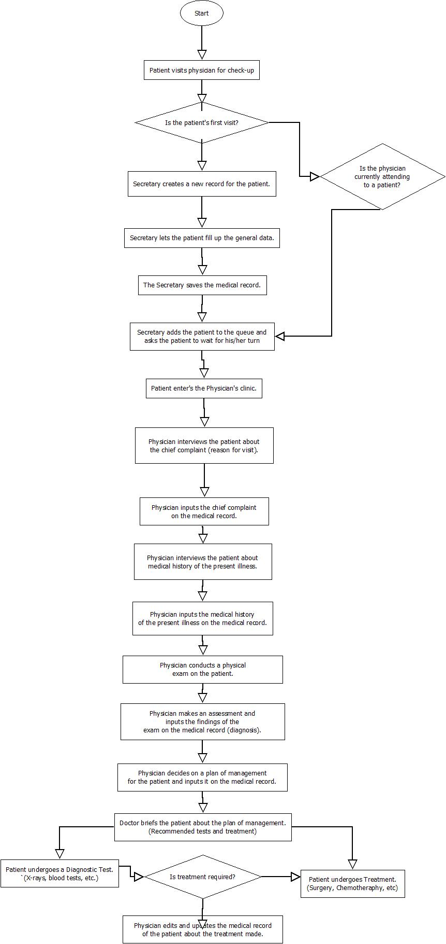

**Appendix B – Interview Transcript**

**First Round of Interview - January 26, 2015**

Jerrick: Good afternoon! I’m Jerrick.

John: I’m John.

William: I’m William.

John: We’re from De La Salle University. We’re here to inquire about the software. So uh first of, can you tell us about yourself and what what do you do?

Ms. Jovy: I’m Jovy Abong. I’m a doctor. I specialize in internal medicine and my sub specialty is allergy and immunology. Presently I am connected with four hospitals where I practice my sub specialty at the Manila Doctors Hospital, Philippine General hospital Asian Hospital in Alabang and De La Salle University in Dasmarinas Cavite. At the same time, I’m also a professor in the college of Medicine of College of Medicine of UP and La Salle.

John: At those places that you worked on, what are usually the problems that your patients have or at least kung ano yung uhm what are the information that they want to have from the doctor?

Ms. Jovy: From the doctor? Usually my patients are allergic patients so they present if they have respiratory allergies, they may present with itchy nose, recurrent sneezing, runny nose, nasal stuffing. If they have asthma they may present with difficulty in breathing. If they have skin allergies then they may present with rashes and itch. For immunology, I usually have those patients with recurrent pregnancy loss

John: So right now, what is the current software or are you using a software right now?

Ms. Jovy: No. So what you want is to develop a software right? Okay uhm, our.. I’m also the director of research in La Salle and under the internal medicine, there’s what we call gastroenterology specialty and what we really want to do is to create a database of all cancer in the gastrointestinal tract. So let’s say if the patient comes in with a bloody stool it’s a problem eh, it’s bloody stool. He’s a doctor, he’s from UP.

Ms. Jovy: Uhm they want to create a database

Another Doctor: We hired students to make the database so they started already. They worked for us two months ago, November pa. They started making the database.

John: Basically we’re gonna do the same thing.

Another Doctor: We hired somebody pa eh in the section but this we one we can

Ms. Jovy: So for example soft stools, ah I mean bloody stools. Some bloody stools can be infectious in nature right so you have a set of questions there and if they ended, they’d undergo some, some would be infectious some would be almoranas diba. Some would become a cancer. So usually the procedure is the laboratory exams, colonoscopy, you know all those diagnostic tests and from there, it’s either an atomic, infectious, cancer, etc. So something like that. That’s what we want.

John: Uhm so basically what you need is for the database so that you could know what kind of disease that the patient has uhm

Ms. Jovy: And at the same time, it’s going to be a registry of diseases

John: Yeah you can put and edit the data

Ms. Jovy: So at the end, we would have profile of let’s say for, no I’m just giving an example, so for example.. Can I just show you something?

John: Oh yeah, that would be better po actually. Thank you.

Ms. Jovy: Here na lang, I’m making it for kasi for my lecture tomorrow. Because what we want is after we diagnose a certain group of patients, we want to know the equivalence or the percentage of let’s say bloody stools of a cancer of patients who presented bloody stools. We also want to know their age range, their etc.

John: Okay so parang like the statistics

Ms. Jovy: Statistics, precise

John: Statistics of the patients

Ms. Jovy: And we could do that very easily if you do it, if you make it as a program . I’ll show you later our because we have an algorithm in the diagnosis of rashes because you know when you have rashes, it can be caused by different things, multitude of things. We could make it simpler if we have this database so we could know this.

John: So basically what we can put sa database are the basic na data that we need to store is yung symptoms, uhm yung cause nito. We can, in the database, we can place the disease, or allergy.

Ms. Jovy: Or you can present the symptoms first, okay and from those symptoms, medical history. You know what a medical history is? When did it start? How long? Is it very itchy? Something like that. And then after the medical history, physical examination and then diagnostic tests and then probably you can branch it. So I’ll show you a.. So this is usually what do we do. So this are your symptoms and this is just a very short history so that if it’s positive, it’s probably this. If this one, if the test is positive, then it’s probably this. But of course, this is a very simple one. There should be a lot of diagnostic tests. And there should be a lot of questions here also

John: So the software that you need is yung something that would base sa input which is yung symptoms? And then from that, it’ll ask another question and then in the end it will derive what kind of disease it has, the person has.

Ms. Jovy: Parang ano lang yun, tick lang. Kasi the patient will have to do this diba to answer parang yes or no, something like that. Maybe not really this, maybe it’s another type of disease that we want. It’s still something like this.

John: Uhm so that you could know the disease, yung final disease, what are the data that you need to know first? Besides yung symptoms, medical history?

Ms. Jovy: The lab exam

John: What do you usually look in the medical history so that you can further understand what kind of disease?

Ms. Jovy: Usually, uh I’ll show you something. Actually we already have a journal where we can copy. I don’t know if it’s here. It depends upon the disease but usually of course the first thing would be the age of the patient, sex, the occupation, educational attainment, the socio economic status. Those are the usual ones

John: Because it would also depend on the age noh?

Ms. Jovy: Yes, their capacity to..here. This database for prostate cancer. That’s already an article. This is the database that we use for prostate cancer. This is the prostate cancer research database with clinical warehouse technology for linkage with medical records, something like that. If you want to read that, you can read that. I wouldn’t understand so much kung ano yung database that you could use, I don’t know.

John: Uhm how about in the lab exam po, what are the data na kinukuha nyo po from it?

Ms. Jovy: Depending upon for example, mga chronic. Lab exams would be your blood testing, CBC, urinalysis, measures to detect inflammation. So from there, you have a basic one and to have more test, depending upon the basic test.

John: Right now, where or how do you store your data about the patients?

Ms. Jovy: Paper, diba we have papers, sulat mo dun. I don’t have a database

John: Okay, so based from what we asked and what you’ve told us also, the software that we can create are based on the symptoms, based on the data that will be input by the user, the program will ask a series of questions. It will also need lab exam results, the medical history and from those, it’ll be able to derive the sickness that the patient can possible have.

Ms. Jovy: From the history, from the symptoms, and the physical examination and what is present. We can have a question for example, “Is it likely or unlikely?” That would be yes or no, depending upon the criteria. From there you can, for example, “Is likely? Yes or no. What type of is it? Is it acute or spontaneous or chronic? And then from there, if it is chronic, do we need lab test, something like that. And then the results of the lab exams.

John: Basically it’s a software that asks the patient yes or no questions and his or her answer would cross reference the existing database that we’ll be collecting.

Ms. Jovy: And from there, we’ll know the exact disease or what does the patient have or any ailment. And then from there, do you think we can for example, we have a data registry of let’s say patients with chronic versus acute, something like that. From there, can we get the let’s say, the characteristics with chronic in terms of age, in terms of the underlying cause, in terms of the laboratory profile, something like that. Can we get it from there? I mean in that database? Is that possible?

John: Actually, we can pero uhm we’ll follow you up with that one nalang.

Ms. Jovy: Okay, siguro depende sa objectives. I mean the goal of database, what we want because it seems like a.. When do you need this?

John: End of term.

Ms. Jovy: So uh when is the end of term?

Jerrick: I think mga two months.

Ms. Jovy: Okay siguro, at the end of the week, or early next week, I can give you a brief parang research protocol. You know what I mean, the object, the research question, short objectives so that you will know how to go about it.

John: When you say research questions po, uh example po.

Ms. Jovy: For example uh, let’s say a research question is like a general objective. So example my general objective is at the end of the uh yung database, among patients with uh I want to describe the profile of patients with chronic using this database, something like that. That’s a very simple one. Or I want to determine the diagnostic approach using patients with using this database. I’ll give it to you at the end of this week so that you’ll have an idea what the database is going to be used for. Kasi di nyo din alam pano, ano yung ilalagay dun kung di nyo alam san naming sya gagamitin tsaka exactly anong sakit, marami yun. Di pwedeng isang database.

John: Kaya naman pong isa pero malaki. We’ll follow up you nalang up kung anong features yung kaya naming magawa.

Jerrick: Thank you for your time.

Ms. Jovy: Oo, I hope I was helpful.

**Second Round of Interview - February 14, 2015**

Naomi: Hello. Good evening Ms Jovy Abong

Ms. Jovy: Who is this

Naomi: Hello Ms Jovy. I'm Naomi Mendaros, project manager of Team Chocnats. I'm William's classmate.

Naomi: We're here for an online interview po. Can we take 30 minutes of your time?

Ms. Jovy: are you his group mate?

Shaila: Ms. Jovy Abong. We're the groupmates of William Dionio for a project.

Naomi: Yes po.

Ms. Jovy: What can I do to help you?

Naomi: I and Shaila Choa would like to ask some follow up questions po regarding the software that will be used for the patients' records.

Ms. Jovy: Go ahead

Naomi: Who does the records of the patients po? Is there a secretary or the doctor does it as well?

Ms. Jovy: The doctor writes it down as he interviews and examine the patient

Naomi: Does this include personal information like name age educational background etc?

Ms. Jovy: Yes that's is the first thing we do . It is called general data

Shaila: Will the doctor be the only user of the software?

Ms. Jovy: It include name age sex nationality address religion occupation and number of times patient has been admitted

Naomi: Is it just the doctor who manages/views the records of the patients?

Ms. Jovy: The physician in charge is the user of the software. If this is going to be used for research purposes then the researcher can use the data as long as the research is approved by ethics committee

Ms. Jovy: If it's for research then informed consent from the patient should be obtained first

Naomi: Will there be just a single doctor or there will be more than one doctor who'll manage the data?

Ms. Jovy: It depends. If it is a group practice then the doctors in the group will manage it. Sometimes the doctor can delegate it to his nurse or secretary or a resident doctor ( under training)

Shaila: Does this mean that every user of the software can add/edit information on the database?

Naomi: Also do they have specific tasks like the physician can view and edit the data while the researchers or practitioners can only view the data?

Ms. Jovy: They can add information when the patient comes for follow up to monitor her progress and response to treatment and review results of diagnostic exams

Ms. Jovy: You are correct. Researches can't edit or add or tamper with the data

Naomi: Thank you po. So the possible users would be the physicians and researchers only?

Ms. Jovy: Yes

Shaila: Will all physicians have the same username and password to the software? Or will they have individual accounts for them to have access to the software?

Ms. Jovy: Individual accounts. Patients records are confidential

Shaila: Noted, thank you.

Naomi: If there will be different users with different tasks, what would be the tasks of each users?

Naomi: Or what data can they only view/edit?

Ms. Jovy: It depends on purpose. If it's a resident who wants to present data in conference he can obtain just the results of diagnostic tests

Naomi: What else po?

Ms. Jovy: If it's the researcher then he can use all the data provided it has been approved by ethics committee and with consent from doctor and patient

Naomi: Thank you po. Regarding the accounts of the users, will there be an admin who can manage users?

Ms. Jovy: I don't understand the question .Admin?

Shaila: Miss, will there be someone who can manage all the physicians' account?

Naomi: As well as the other accounts po

Naomi: Like it can delete or add accounts for the users of the software

Ms. Jovy: If it is an account for all specialty doctors then that would be best

Shaila: During the past interview, you've mentioned about statistics. What results from the statistics you want to retrieve/view?

Ms. Jovy: Depends on the Objective of the research. Usual are proportion mean relative risks odds ratio anova etc

Naomi: Sorry Ms. Jovy, what do you mean po by anova?

Ms. Jovy: Analysis of variance

Naomi: Can you give us a list of results that are needed po?

Ms. Jovy: I can't because we don't have research proposal yet

Naomi: Okay po.

Naomi: Ms can we have a sample copy of the data you keep track of?

Ms. Jovy: I gave Paolo the data Re ore form we use in pgh

William: Regarding the expert system po, I think we will not be able to implement it in a short span of time

Ms. Jovy: Ok

Naomi: Hence we can only implement the database for the patients' record only for this term ( January - April )

William: We are sorry for the inconvenience po as the system will require a large amount of rules in order to come up with an accurate diagnosis

Ms. Jovy: Ok

Ms. Jovy: The physician will come up with the diagnosis not the program

Naomi: Okay po Ms Jovy.

Naomi: Kayo po, do you have questions po ba?

Ms. Jovy: none good night

Naomi: Thank you po Ms Jovy! We'll just contact you for other concerns in the future. Good night!

Shaila: Thank you so much for your time

Shaila: Ms. Jovy! Sorry for extending. Have a good night!

Sorry Ms. Jovy, I have received the sample data na po. We'll try to review it tonight. Will you be available po tomorrow for some clarifications if ever?

Ms. Jovy: Not on a Sunday

Naomi: Okay po Ms Jovy. Thank you!

Naomi: Sorry for the inconvenience po.

**Third Round of Interview - March 1, 2015**

John: Good Afternoon. We're gonna confirm the business process that we derived from the past interviews.

Ms. Abong: This is PGH or yung society namin?

William: Depende sa 'yo kung...

John: Where it can be used po...

John: Ito yung na-copy namin from last time.

John: When the patient arrives po sa clinic we determine first if it's the patient's first visit and then if it's the patients first visit, the secretary asks for

Ms. Abong: a medical form from the physician

Ms. Abong: She has these forms already then she goes gives it to the

John: To the secretary?

Ms. Abong: No, the secretary will give it to the patient and the patient will fill it up what's inside would be the name, the age, the sex and status of the patient whether married, widowed and address, that's all and the contact number.

John: Okay so once it's filled up, they'll give it to the secretary

Ms. Abong: They'll give it back to the secretary and when it's the patient's turn, to see the physician, he will be called and then the form will be given to the physician

John: The secretary will hand it over to the physician?

Ms. Abong: Oo. And the physician will interview

Okay.

John: Regarding the follow-up, when it's the patient's second time visiting

Ms. Abong: Pwede bang pumunta na lang kayo sa clinic ngayon? Para makita niyo yung flow.

Apple: It's okay po.

John: Okay po.

Ms. Abong: Para ma-imagine niyo kung paano siya anyway and then once the patient's follow up, so it's not his first visit, so let's say after three years or two weeks

Apple: He or she will up fill the form?

Ms. Abong: No more she will just tell my secretary "This is my second visit" and then my secretary will get the file. Alphabetical naman yun and then retrieves it then gives it to me.

Apple: May nakuha po kaming form na it's says follow up po where the patient writes his or her current illness

Ms. Abong: Hmm no. Usually the physician will fill that up so when the patient comes we ask her "Okay what is wrong with you now" or if it's let's say a follow up after two weeks of treatment we wants to know how he's responding to the particular medications, his symptoms and his conditions, relieved or treated so the physician will fill those information up based on the questions or the patient will come back with the results of the diagnostic let's say cbc and the physician will look at it and say "Oh yes you have infection" let's say he'll review the x-ray and say "You have pneumonia, this is what we're going to do"

John: So once that form's filled up by the physician, where will it be handed to?

Ms. Abong: It will just be a record of what are the finding are for that moment for example, she comes with a cough, I will listen to her, how many days has she had cough, what is the color, etc. They have fever then I will take her temperature, listen to her lungs and then prescribe medicine and laboratory test, the next time she comes back I will read her x-ray, her cvc, I will prescribe appropriate antibiotics then I will take her temperature again, listen to her lungs and see what has improved, ganun Once you have those information... I will write them down On a form?

Apple: This form po ba? *Shows a form*

Ms. Abong: It's a blank form. This is a follow-up form.

John: This follow-up form will be filled up by?

Ms. Abong: The physician. It's always the physician.

Apple: Once it's filled up, do you give it back to the secretary?

Ms. Abong: For filing. So the secretary will handle the filing of the files.

Apple: I have another question po. The case number for the follow up form is the same with the original form?

Ms. Abong: It's the same.

Apple: The case number will be the same for every patient?

Ms. Abong: For every patient.

John: Thank you po.

John: Since the system is record based, are the only things it can do are doing editing and managing of input data? Viewing, editing and then managing?

Ms. Abong: Yes. But the purpose of this is that so that we can come up with let's say. How many of let's say, you know some generalizations like, "How many patients come in with sneezing in a month?" so the proportion over 100 let's say, 5. Or "How many of these are allergic rhinitis patients? How of these are asthma?" or "What is the range of the ages?". You come up with all those things so if we don't do a database, we'll have to manually do it, diba. For Dr. Bacuyan or the patients as a whole, lahat ng patients ng doctors. If this is gonna be for PGH, then's if just gonna be in one room, ah, it's an outpatient department and then there are about 6 allergologists there inside and then one secretary and one nurse so if it's gonna be placed there, then one database, or one laptop laptop with database for each then they will have a uniform record then they'll put it in the computer so they'll just retrieve it. Because you know, every month we have a census so if we don't do a database, like now, it's hard for us to do the census. If we have 500 patients, how many of them are drug allergies? how many of them are asthma, their ages are like this how many male, how many female?

John: When we say reseachers, we mean people who want to see the statistics?

Ms. Abong: For example if it's a society, each consultant will be given this database and the secretary, we have two secretaries in the society, we can, you know, centralize this. But the ones who can access these are the members of the society. If it's in PGH, the once who can access this would be just the consultants and doctors of section of allergy.

John: Also the doctors will have access to the statistics?

Ms. Abong: Yes.

John: Okay. How about the secretary po?

Ms. Abong: The secretary, yes because they will be the one to manage, administrate.

John: Yung secretary ng buong department po?

Ms. Abong: Ng section. Kasi let's say PGH, it has different departments, department of medicine, department of surgery, department of pedia, department of OBE. For the department of medicine there are sub-specialties, cardio, neurology, pulmonary allergy, so each of those sections will have a secretary

Apple: Can we have an example result of that census

Ms. Abong: I don't know.

Apple: Ah it's okay.

Ms. Abong: We don't have these existing in our society, so as chair of the research committee, gusto sana naming may ganito para we could have a census of let's say, "How many in the Philippines have allergic rhinitis?" because all the sub-specialists, allergies, are scattered through out the country so they will see all these patients because they will be referred to her so how many of these, let's say, 5000 of these patients have allergic rhinitis?

John: In this census, it matters on what time period, the data?

Ms. Abong: Yes.

Apple: Has it already happened that there has been a lost of data?

Ms. Abong: The existing one that we have? Oh, yes!

John: What do they do to cope up with this problem?

Ms. Abong: Kawawa yung mga patient. Kasi they can't do anything about it. Kasi let's say after 10 years, they will be archived in the record section. Can you just imagine the papers there kung may mga anay, kung may nasunog, kung may nabahaan edi wala na, diba? Tsaka often yan even in my clinic, when the files are really lost.

John: When there is an epidemic or outbreak, is there a way for the physicians to be informed of this occassion?

Ms. Abong: Well these are allergies, these are chronic disease kasi inherited so wala siyang, kumbaga, it's not like an infection na magiging epidemic siya but if for example, we want to know how many patients, because we want to know in certain times of the year, there will be

more allergic patients who have the symptoms, they are very acute, we want to know if for example, whether weather in the Philippines like ngayon diba mayroon medyo malamig, will affect them so I want to know na "Will the census for allergy consult increase during the months of December to ganyan" diba. So by that, you can infer na "Ay, oo nga, madami sigurong nagkakaroon ng allergy pag December kaysa pag summer" so we can get it from there. So madaming, kumbaga, thousands of information can be obtained from the database.

Apple: I have a question po regarding the forms. Was there an instance na po ba na naubusan kayo ng forms when a patient arrives?

Ms. Abong: Oo. This is PGH then, oo naman.

Apple: What do you do when this happens?

Ms. Abong: Nagpapa-photocopy or we get the form then just place it in a piece of paper then when the forms are available we just transfer.

John: Confirm ko lang po lang ulit mga magiging users ng system... it will be the physician, the secretary...

Ms. Abong: Yes and the researcher, who is most of the time the physician. Because if he is not, let's say, is not from our society, if we're gonna use this for our society, and he's not from the society, then we will not allow him to view the data. The usual researcher will be the members of our society, which are all doctors.

John: But is it possible that this researcher is not a doctor?

Ms. Abong: Possible rin kung papayag kami. For example he is the co-investigator so let's say I am the principal, he's the co-investigator, he's not a doctor, I tell him to access it then he can ask with permission.

John: In that case po, the co-investigator po, yung na-aacess niya sa system is yung statistics lang talaga.

Ms. Abong: He can access the information that is relevant to the research.

John: Okay.

Ms. Abong: But before we can do research, it has to go through ethics committee. Before we can use this for research also we have to ask the patient for an informed consent.

John: We were actually thinking, so that we could have the consent of the patient, we will include it in the form that will be filled up by the patient.

Ms. Abong: Oo mas maganda yun pero yung informed consent na iyon, has to be approved by the ethics committee.

Apple: In your current business process po, paano po yung process with the consent form between the patient and the physician.

Ms. Abong: Kasi depende sa study design. For example I want to know how many of this [ph?] in PGH, so I will write now a research protocol and submit it to ethics. Now if there's no invasion of the privacy of the patient and it will do it no harm. For example it's your record but we won't reveal your name, we will just say "58 over 100 who came to PGH have asthma", and one of the 58 is you but wala ka namang pangalan dun etc etc then you don't need an informed consent for that.

John: Will it be a big help if there's a informed consent?

Ms. Abong: Yes.

John: What will be the extra data that you will be able to get?

Ms. Abong: From the informed consent? Kasi we have, in research kasi, we have to protect the patient's privacy, his safety, etc etc. So doon lang yun yung informed consent nanggaling kunwari, I have to reveal, for example, a to my genetic workup and then we have to reveal kung ano yung mga genetic makeup niya even if it's just restrospectively then probably we really have to get an informed consent. So depende actually sa study design.

John: Is there a set of data specifically that would need an informed consent?

Ms. Abong: The first one usually is the purpose of the research, the title of the research, since wala naman tayong title sa research na 'to, I don't know if we can get an embanked informed consent request so... the title, the purpose, the benefits for the patient, the procedure, what you're going to do so the patient will know, the assurance that the patient's privacy is safe, and the assurance that he can withdraw or he can decline participation, the contact person, the

primary investigator, that's usually the confirmed consent but I don't think we need an informed consent here because we don't have a specific research protocol yet.

John: So retrieving the data anonymously would be enough po?

Ms. Abong: Parang ganun, yeah, I mean if it's just statistics, oo. Pag statistics hindi naman ikaw hinihingan ng informed consent.

Apple: I have a question po. Yung regarding po sa researchers, parang magsusubmit po sila ng proposal sa ethics committee?

Ms. Abong: No, no. They will make a research proposal and then yeah, submit it to the ethics committee.

Apple: And then the ethics committee will return the paper if they have approved it or not to the researcher po?

Ms. Abong: Oo.

Apple: Okay po.

Ms. Abong: Depende iyan ha sa institution so the ethics committee of the insitution where you will get the patients.

Apple: Okay po.

Ms. Abong: For example, sa La Salle de dun ka mag-submit ng protocol mo for the ethics committee, La Salle, sa PGH, sa PGH.

Apple: I guess this is all for now po. We're will po na sumama sa clinic niyo today.

Ms. Abong: Ah gusto niyo sumama?

Apple: Okay lang po kami ni John.

Ms. Abong: Okay, sige. Sama kayo?

Apple: Opo

Apple: May c-clarify lang po kami regarding sa admin. Willing po kayo maghire if ever po ng admin?

Ms. Abong: Depende sa ano niyo, sa research

Apple: Ah research po? Pero yung, kunyari, yung mag-a add pong user na physician, secretary. Yun lang naman po usually gagawin ng admin.

Ms. Abong: If we’re going to use this sa society, meron kaming dalawang secretary so sila actually yung nagm-manage din ng website namin. May website kasi kami and then we also have a, anong tawag doon? Basta ano sila, it’s a company that helps us with the mga interactive sessions naming. Kunyari online kukuha ng exam, kunyari may scientific lecture kami afterwards may exam. Sila yung and then they’re also the ones that are helping us with the website

John: Yung gagawin po kasi ng admin, may inisip po kasi kaming feature na there will be user accounts so when you log-in to the system, kunyari kayo po, magl-log-in po kayo and then you can access the data base, you can view them so yun po yung mga pwedeng gawin ng physician and kunyari may account din po yung researcher, ibang account naman po and pwede nya lang gawin

Ms. Abong: To ensure privacy

Apple: Yes, Opo

Ms. Abong: Na hindi sya pwedeng ma-access

John: And security din po

Ms. Abong: Gusto rin naming yan. Actually yung website din naming may account din and password for each member

John: Tapos parang ganun po, yung researcher po yung makikita nya lang po yung data. Right now po diba sabi nyo po may mga account po kayo?

Ms. Abong: Sa website namin

John: Sino po yung nag-a ano or at least sa iniisip po naming system, sino po kaya yung maghandl ng mga accounts, yung pwede po mag-add ng accounts for a new doctor or yung

Ms. Abong: Yun nga, yung nagha-handle ng interactive

John: Ah yung secretary po?

Ms. Abong: Hindi, meron kasi kaming isang hina-hire talaga

John: Ah may company po

Ms. Abong: Na company. Ano bang tawag sa mga company na ganun? Di ko alam.

Apple: Di po ba consultant

Ms. Abong: Well he is, he is. Well hindi sya doctor, he’s a PhD in mga ganyan ganyan. Tapos meron silang firm who handles this mga.. Ang gusto nila yung mga ganun for education ng mga doctors . So for example, I want to, we have this units Continual Medical Education units we have to have a certain number of units so we can renew our PRC ID, yung sa doctors professional so pwede naming i-submit yun,we’d just take the exam. SIla yung gumagawa, nagde-design ng mga interactive sessions and exams nay un.

Apple: This is online po?

Ms. Abong: Online, oo. So may link kami sa kanila. Tapos sila din tumutulong ng website naming.

Apple: Dito po sa system, preferred nyo po ba na sila rin po yung maghandle ng accounts

Ms. Abong: Di ko nga alam eh. I have to talk to the society. So anong suggestion nyo?

Ako po, maganda po sana kung within the department po

Ms. Abong: Meron, so that would be the secretary

John: Para kase sya nakakaalam sino po yung, if there will be a new doctor or umalis po yung isang doctor ganun po.

Ms. Abong: Sige.

Apple: Yung sa magiging system po, tingin niyo po sino yung pwede pong magrestrict ano po yung mav-view ng mga researchers since meron pong ibang data na di pwede nila Makita. Sino po yung magsasabi or maglalagay sa system po kung ano lang yung pwede nila ma-view? Sino pong tao?

Ms. Abong: Hindi ko alam. Sino kaya?

Apple: Yung admin na din po?

Ms. Abong: Oo

Apple: Yung secretary po.

Ms. Abong: So kunyari ako may researcher ako, ito lang yung kailangan kong data. Yun lang yung i-v view ko. Sabihin ko dun sa secretary na yun lang pwede i-view naming ng assistant ko. Kasi tinuruan din sila eh.

John: So itong secretary pong ito. Siya po yung secretary ng buong department?

Ms. Abong: Yeah

John: Okay

Ms. Abong: Dalawa sila.

John: Pero secretary din po ba yung tawag sa nag-a abot po ng forms sa inyo, si Ms. Lai po.

Ms. Abong: Oo, kasi secretary sya ng doctor. Iyon, secretary ng society. So wala syang kung baga so society namin, doesn’t handle patients perse kasi it’s a society of “………..”

John: Okay.

Ms. Abong: So sa office lang siya.

John: Iniisip po naming if it will be useful for you po kung irerefer nyo po yung data from another patient. Kunyari i-c compare nyo po sa situation ng current patient nyo po tapos parang i-re reference nyo po yung nangyari sa another patient. Kunyari..

Ms. Abong: Ano nga ba yung ginawa ko dun sa pasyente na yun?

John: Opo

Ms. Abong: Parang ganun? Oo, pwede kong tignan.

John: San po kami makakakuha ng sample po ng census? Hingin ko yun .

Ms. Abong: Sige po follow –up nalang po.

John: Pero pupunta akong pgh March ano pa

Apple: Second week po or first week?

Ms. Abong: Not next week. March 10 pupunta ako dun.Kaya before that, iremind mo ‘ko.Pero that’s only the census for the month. It’s just the sample of the census but it’s different if it’s a research. Depende kasi kung ano yung gusto mo.

John: Pero yung research po, isn’t that the census po?

Ms. Abong: No

John: It’s different po?

Apple: Yung data po sa census, almost the same po every month yung mga data na kinukuha po?

Ms. Abong: Oo the same, yung mortality, morbidity, yung mga how many patients “…………….”, at the opd, how many were adults, how many yung asthma, ganun.

John: Is it possible we can the full list po noon

Ms. Abong: Ay yoon ipapakita ko sa inyo kasi nandun lahat iyon.

Apple: Yung current process nyo po for the census, di ba sabi nyo po nire-retrieve lang ng secretary yun one by one yung mga papers po. Pano po yung pagtally nyo? Nilalagay nyo po sa paper yung results or sa computer. Excel po ba?

Ms. Abong: Ay hindi ko alam. Palagay ko. Usually ang gumagawa nyan would be the doctor in charge for that month

Apple: Hindi po secretary?

Ms. Abong: Hindi. Sya yung kumukuha lahat ng census nya the records ng secretary

Apple: Tapos yun po, manual po yung pagtally?

Ms. Abong: O kaya i-enter nya sa computer

Apple: Pero kayo po, na-experience nyo na po ba magtally or not yet po?

Ms. Abong: Oo kasi matanda na ‘ko. Dati wala namang bago lang yung excel

Apple: Pero pano nyo po tina-tally yung dati?

Ms. Abong: Ano, manual.

Apple: Ah paper po

Ms. Abong: Okay meron din naman, tinatally din naman tinatally namin sa excel. Later on yun nagexcel na din kami. Pero nung umpisa, manual. Okay na?

John: Okay po

Apple: Last na po, kasi nakita po naming, yung sa ibang patients po inaabot po ng secretary yung chart or yung record po tapos meron din pong kasama yun na syringe and yung medicine po?

Ms. Abong: Oo. Ay depende kasi yun sa case ng pasyente

Apple: Other than yung medicine po, ano po yung other possible na binibigay din po kasama ng chart?

Ms. Abong: Wala. For example, for a skin test, the skin test is there.

Apple: Dpende po sa gagawin ng pasyente?

Ms. Abong: Depende, oo. May iba naman naman na vaccine lang, oo.

Apple: Yun lang po Ms. Thank you po!

Ms. Abong: Sige, oo.

**Interview with Secretary - March 1, 2015**

John: Doon po sa mga form na finifill up ng patient, pag na fill up na po siya, i-aabot sa physician, kay doc, tapos ilalagay na po niya notes niya regarding doon sa check up po?

Sec : Yes oo.

John: Tapos after po?

Sec: Ibabalik sa akin, tapos i-fifile ko na siya.

John: Okay. Kapag bumalik naman po yung patient and may record na po siya?

Sec: Hindi na niya kailangan mag fill-up ng new record, hahanapin ko na lang yung short niya, tapos yun na yung ibibgay ko kay doktora.

John: Ano pa yung iba pang papers na kasama ng form po?

Sec: Ah yung file? Halimbawa nag request ng lab test si doktora, yun yung kasama sa next visit nila, ipapakita nila yung results nila tapos yun yung i-aattach doon sa file nila para may kopya pa rin kami.

John: Ah okay. Doon po sa secretary and doctor, one is to one po ba, like isang secretary po naka-assign for one doctor?

Sec: Usually ganun, pero may ibang doctor lalo na kapag maraming pasyente, or may mga procedures din sila sa clinic, minsan may tatlong secretary, minsan dalawa sa isang doctor.

John: Okay. So confirm ko lang po ulit, yung kasama po nung file ng patient po is yung unang form na finill up po nila and yung lab results po?

Sec: Oo. Kung meron.

John: Okay, na gagamitin ng physician.

Sec: Oo.

John: Okay thank you miss!

John: Miss, kanina po na-mention niyo na it’s possible po na magkaroon ng multiple secretaries assigned to one doctor, is there a specific number of patients na nag mag-ccause po na kailangan dalawang secretaries ang assigned?

Sec: Hindi ko alam, pero di kasi sa amin, kahit gaano ka dami yung patients, okay lang kahit isang secretary kasi more on charting lang naman and wala namang mga procedures so okay lang din. Pero sa ibang clinic kaya din sila may multiple secretaries kasi minsan katulad ng isa naming doctor na inassign sa kilala kong secretary, nag chechemo therapy yung doctor dun sa mismong clinic so kailangan niya ng dalawang secretary.

John: Kasi sila din po mag-aassist?

Sec: Oo, hindi siya depende sa kung gaano kadami ang pasyente.

John: Depende po sa ginagawa talaga?

Sec: Oo.

John: Okay. Is it possible naman po na isang secretary for multiple doctors?

Sec: Oo. Katulad ko, dalawa yung boss ko. Si doktora Abong at si doktora Espiritu, iisang secretary pero dalawang doctor kasi magkaiba ang schedule.

John: Okay kasi different time slots po sila?

Sec: Oo. Different schedule.

Apple: Yung isang doctor po same po sila ng field ni doc Abong?

Sec: Ah oo. Si doktora Abong immunologist, si doktora Espiritu ENT siya and allergist.

Apple: Yung patients po nila different?

Sec: Magkaiba.

John: Sa field po na to, usually po ba talaga isang secretary lang?

Sec: Hindi ko masabi, depende talaga. Pero minsan din kahit more on charting lang din meron din secretary na dalawa sila sa isang clinic.

John: Hindi rin po talaga consistent?

Sec: Oo.

Apple: May nabanggit po kasi na website si miss Abong kanina, kasama rin po ba kayo sa mga may user accounts doon sa website?

Sec: Hindi, doctors lang.

John: Okay thank you po!

**Appendix C – Sample Forms and Reports**

**C – 1 Allergy and ADR Form with Follow up Form**

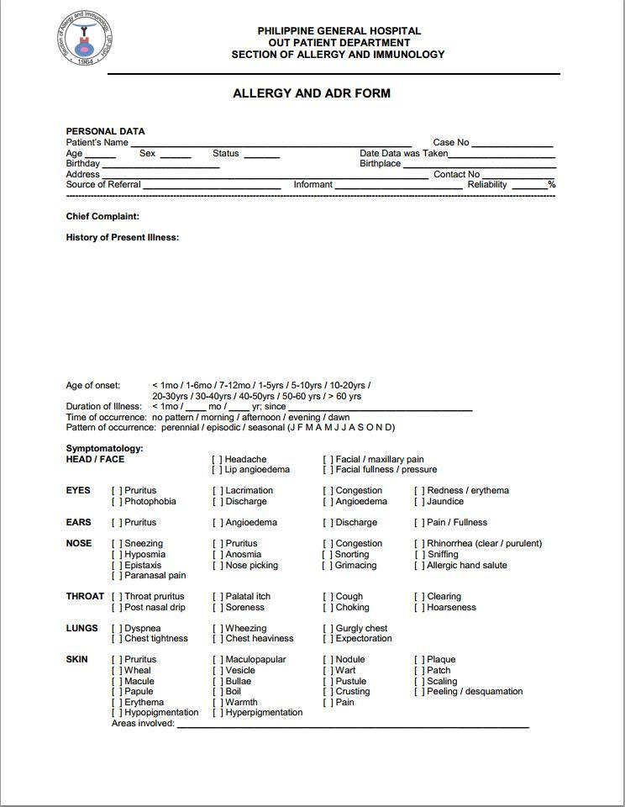

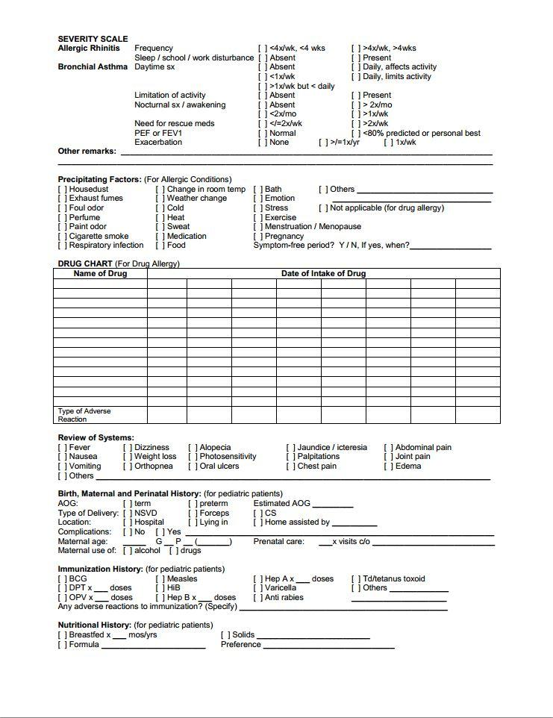

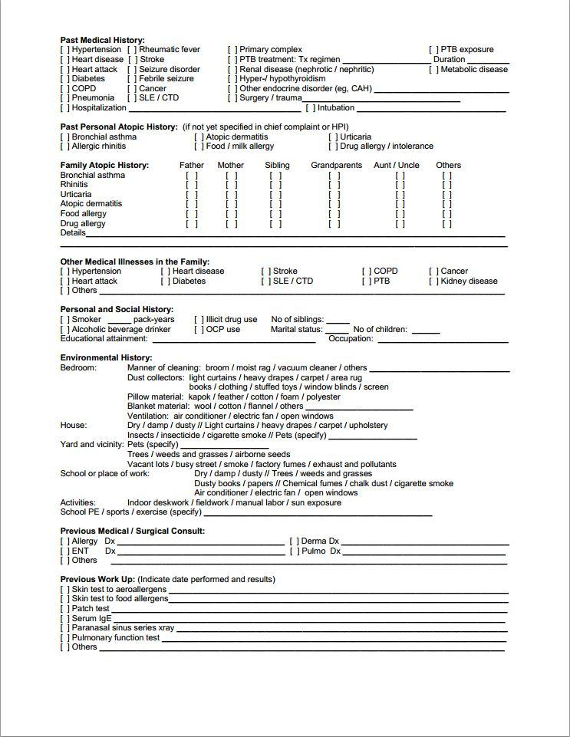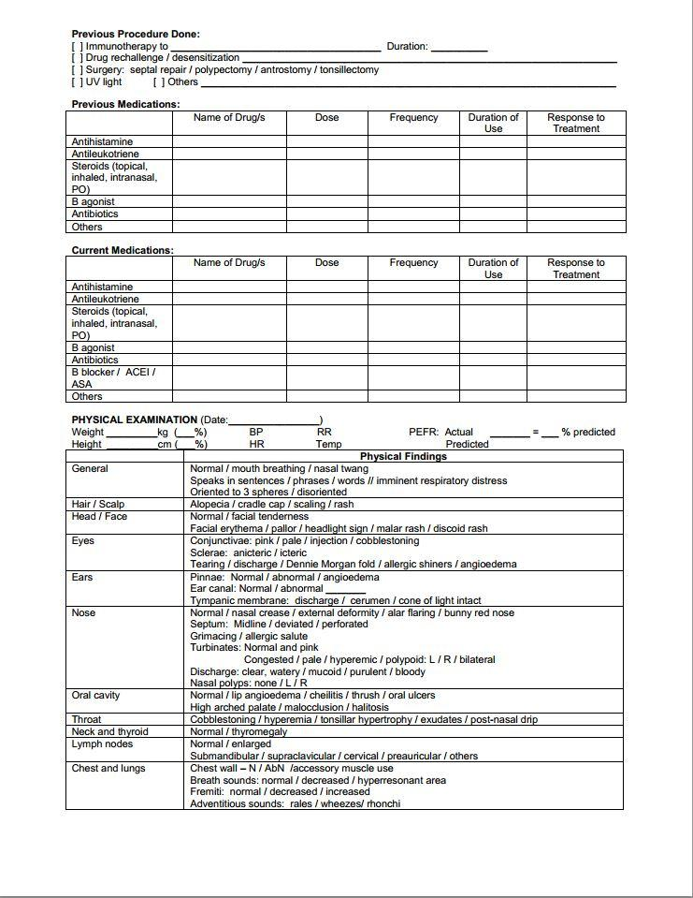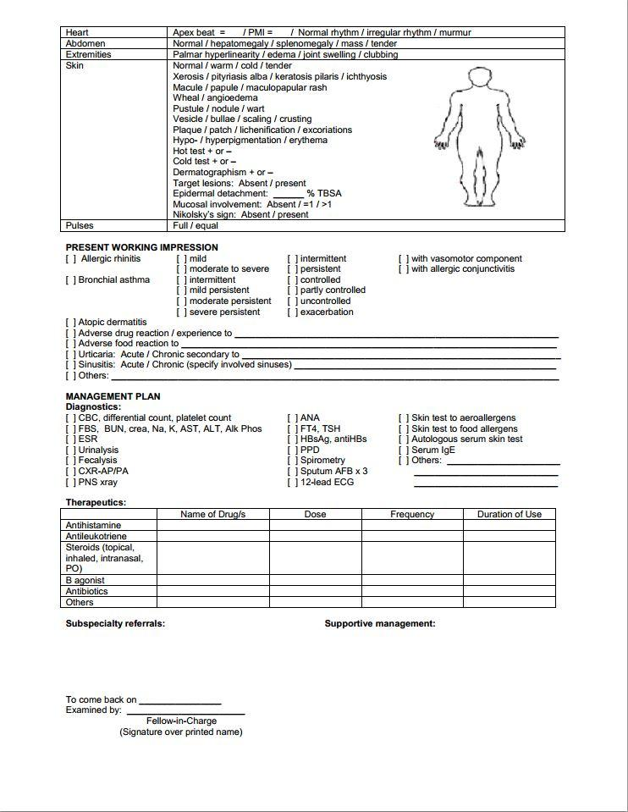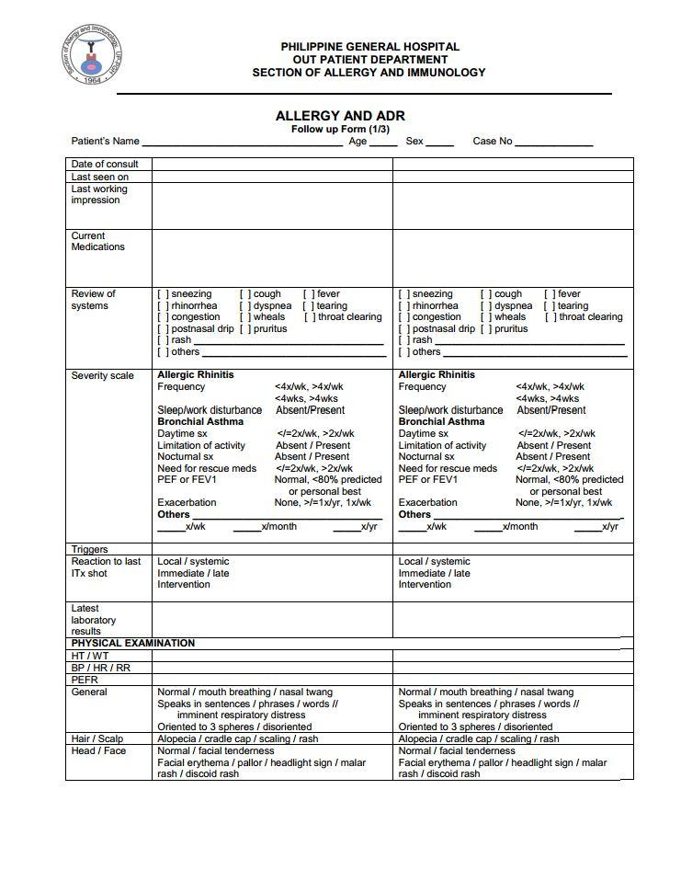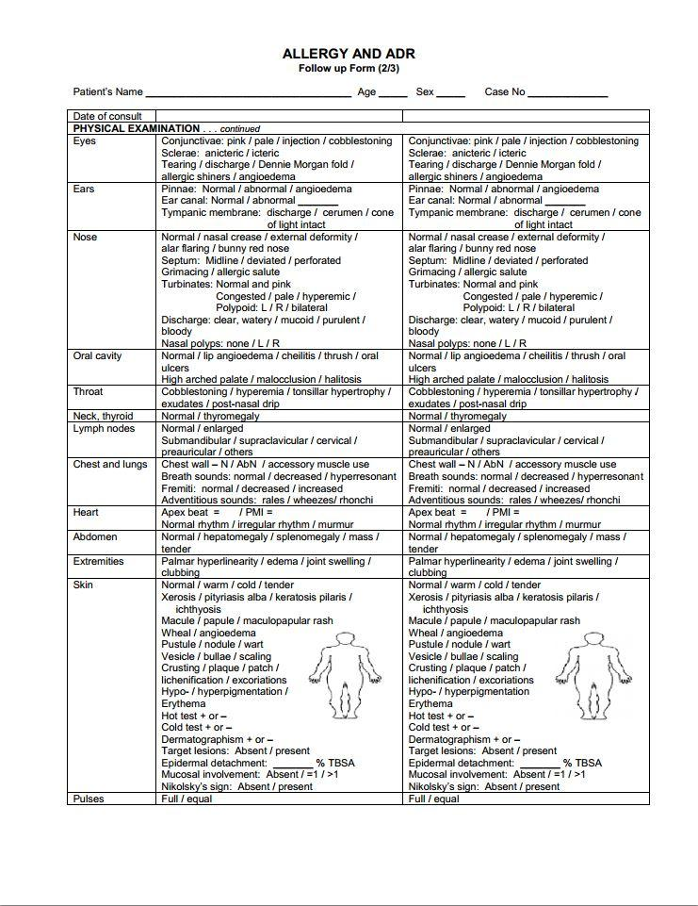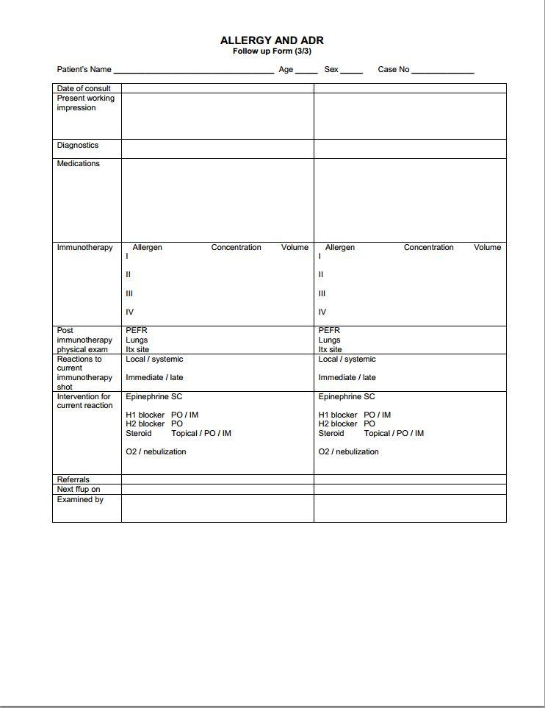

**Appendix D – References and Acknowledgement**

*This section allows you to properly cite all materials that you used, be these in the form of books or online resources. You must also acknowledge any person(s) and/or organization(s) you have interviewed or gathered the information from (name, position).*

The team would like to acknowledge Dr. Jovy Abong for her time and patience working with us. She provided all of the necessary information, including the forms used during actual consultations the team needed to carefully and meticulously analyze and design a system that would fit the needs of her organization.

The team would also like to acknowledge Manila Doctors for allowing the team to observe the actual business process on-site. The team would also like to thank the secretary, Lailani Reyes, who gave her time to share information about how business process goes from her perspective.

Online sources:

* http://www.asianhospital.com/
* https://www.philippinemedicalassociation.org/